Our Map of Online Safety Needs & Priorities

RULES OF NETIQUETTE

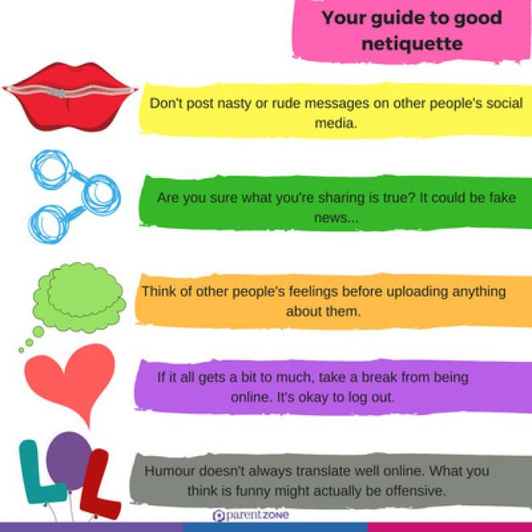

"Netiquette" refers to Internet etiquette. Netiquette is a combination of the words network and etiquette and is defined as a set of rules for acceptable online behavior. Similarly, online ethics focuses on the acceptable use of online resources in an online social environment.

Rule 1: Remember the human.
Never forget that the person reading your mail or posting is, indeed, a person, with feelings that can be hurt.
It's not nice to hurt other people's feelings.
Notify your readers when flaming.

Rule 2: Adhere to the same standards of behavior online that you follow in real life.
Be ethical.
Breaking the law is bad Netiquette.

Rule 3: Know where you are in cyberspace.

Rule 4: Respect other people's time and bandwidth.

Rule 5: If You Wouldn't Show it in Public, Don't Share it Online

Rule 6: Respect People's Privacy

Rule 7: Don't Repost Without Checking the Facts

Dos
* Respect other people's privacy
* Verify facts before reposting
* Check messages and respond promptly

Don'ts
* Name-call or express offensive opinions
* Post private or embarrassing images or comments
* Exclude people or talk behind their backs

COPYRIGHT

(source:https://agla.gov.tt/intellectual-property-office/copyright)

What is copyright?
This is a property right, which subsists in literary and artistic works that are original intellectual creations. Works covered by copyright include, but are not limited to novels, poems, plays, reference works, articles, computer programmes, databases, films, musical compositions, paintings, drawings, photographs, sculpture, architecture, advertisements, maps and technical drawings.

ANTI-CYBERBULLYING
Useful Links for anti-cyberbullying:
https://anti-bullyingalliance.org.uk/
https://www.actionforchildren.org.uk/
https://www.bullying.co.uk/

e-SAFETY
Useful Links for e-safety:
https://www.betterinternetforkids.eu/
https://www.unicef.org/child-rights-convention
https://www.saferinternetday.org/web/sid/home
https://www.saferinternetday.org/web/sid/resources/gallery

GENERAL DATA PROTECTION REGULATION (GDPR)

Follow the rules written here:
https://gdpr-info.eu/
